Final Term Examination (Fall-2022)
Computer Networks
CS-577
Registration No.__________________________Total Time: 1.5 hours Maximum Marks: 30
------------------------------------------------------------------------------
Question 01: What are different steps involved in Link State routing. Find the routes in figure below from node A to all the other nodes in the network using Dijkstra’s algorithm. Marks:06
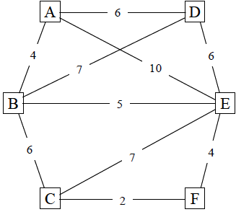

Question 02: A)Collision is an issue in random access protocols but not in controlled access and channelization protocols. Explain why or why not.
B) What fields exist in both TCP header and UDP header? Which fields in TCP support the error control in segments transmission? Marks:3+3=06

Question 3: Given the dataword 1010011110 and the divisor 10111, Marks:3+3=06
A) Show the generation of the codeword at the sender site (using binary division).
B) Show the checking of the codeword at the receiver site (assume no error).

Question 4: A system uses the Stop-and-Wait ARQ Protocol. If each packet carries 1000 bits of data, how long does it take to send 1 million bits of data if the distance between the sender and receiver is 5000 Km and the propagation speed is 2 x 10⁸ m/s Ignore transmission, waiting, and processing delays. We assume no data or control frame is lost or damaged. Marks:06

Question 5: With the help of flow diagram, describe different phases of TCP Reno for congestion control mechanism. The initial threshold value is 28, timeout occurs at round 10, 3ACK occurs at round 20 and draw diagram till round 30. Marks:06

*****Good Luck*****

Final Term Examination (Fall-2022)
Computer Networks
CS-577
PRACTICAL
Registration No._________________________ Total Time: 1.0 hour Maximum Marks: 20
------------------------------------------------------------------------------

Question 1: An ISP is granted a block of addresses starting with 198.215.0.0/16 (65,536 addresses). The ISP needs to distribute these addresses to two groups of customers as follows: Marks:06
A) The first group has 128 customers; each needs 64 addresses.
B) The second group has 64 customers; each needs 256 addresses.
Design the subblocks and find out how many addresses are still available after these allocations.

Question 2: Marks:4+1+1=06
- Draw the network diagram using following addressing Table.
- How many separate networks in the system?
- How you configure the router R1 for assignment of IP addresses through CLI.
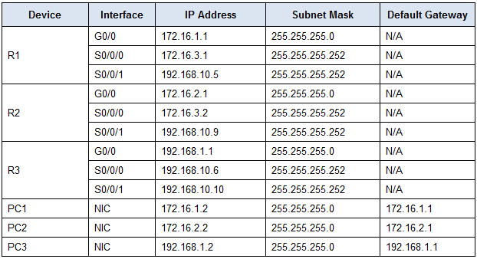

Question 3: Describe your semester project (4 lines Max.) Marks:08

